2023

TRINITY STAR ARTS COUNCIL

SCHOLARSHIP
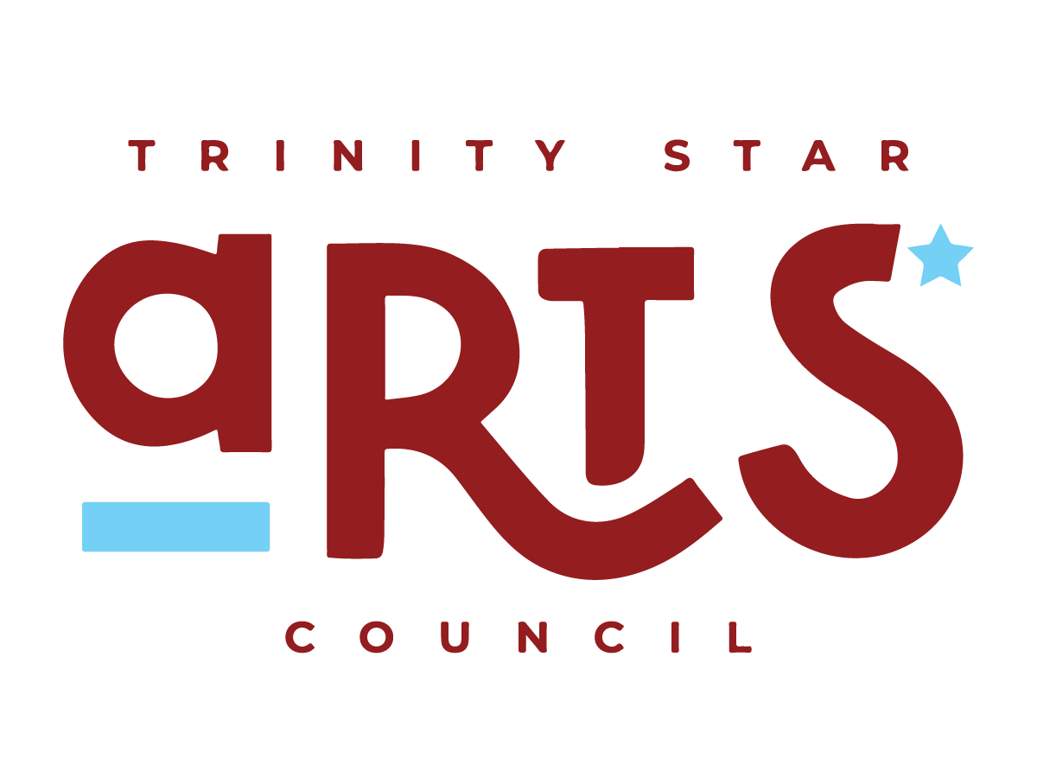

2023 TRINITY STAR ARTS COUNCIL SCHOLARSHIP

Eligibility

1. TSAC will award a scholarship of $1000 each to qualified students during the current school year.

2. Applicants must be graduating from a high school within Freestone County, Texas.

3. The scholarship must be used for enrollment in an accredited college program toward a
degree in The Arts. Scholarship moneys are limited to tuition, fees and on-campus housing only. The award must be redeemed within one year of presentation.

4. Scholarship will be awarded on the basis of artistic merit and artistic potential only.

5. Students must be currently enrolled in a visual or performing arts class and show proven artistic ability in at least one of these areas: Performing Arts (music, dance, theatre), Literary Arts (creative writing), Culinary Arts, Media Arts, Medical Arts (music therapy) and/or Visual Arts (drawing, painting, sculpture, architecture.)

6. Not eligible: TSAC board members, or members of immediate family or dependent children.

Application Process

Application must:
~be submitted to high school counselor no later than April 17,2023
No late or incomplete entry will be accepted.
~be typed or word processed for legibility. Handwritten application will not be accepted.
~be accompanied by two (2) letters of recommendation, at least one of which from a teacher
of the arts who is familiar with the applicant’s artistic work.
Letter-writers should not be otherwise related to the student.
~ include an official copy of the academic transcript, showing GPA
~include an example or photo showing your level of expertise in your chosen art field
~ include a one-page essay describing the role your art form plays in your life, and what role it will play in the future. In general, your essay should reflect your sense of dedication to your chosen art discipline. Suggestions:
Why is your art form significant?
What do you value about being an artist?
What do you hope to gain from an education in your particular field?

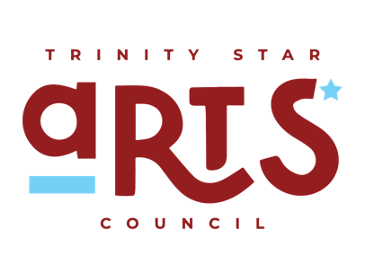

Committee members will evaluate & score each applicant based on the following criteria as demonstrated in the written essay, noted artistic achievements, letters of recommendation and/or interview:
~Proven artistic/academic abilities in dance, literature, music, theatre, visual arts, etc.
~Well defined future goals and objectives relating to the intended field of study.

TSAC Scholarship p.2

Selection Process and Scholarship Award

~Applications will be reviewed by the Arts Council Scholarship Committee.

~Applicants should be available for an interview if requested by the Committee.

~TSAC Board President will be included in the recommendation process to break a tie.

~The Scholarship Committee will make recommendations for scholarship recipients to
TSAC Board of Directors. Decision of the Board of Directors is final.

~A Scholarship Award Certificate will be presented to the recipient by a TSAC Board member at the recipients’ school senior awards ceremony.

~Check will be forwarded directly to the college or university upon receipt of a copy of the student’s official enrollment, including student ID number.

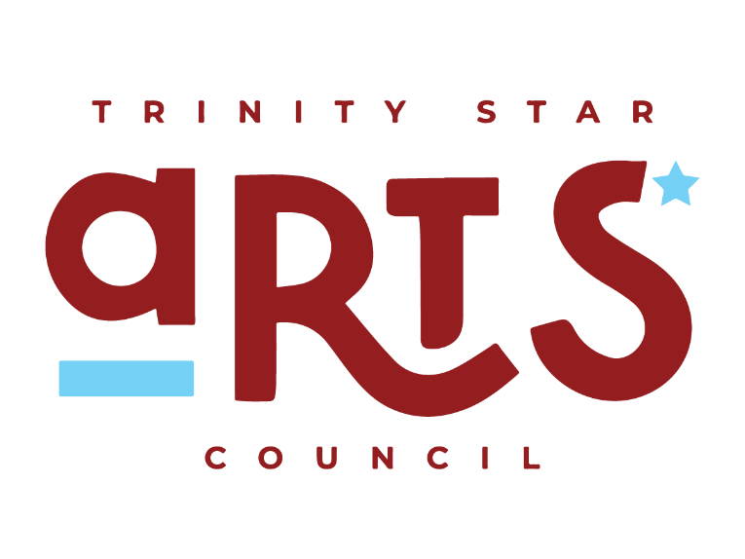

Trinity Star Arts Council is a non-profit, non-discriminatory organization whose mission
is to present performing, literary and visual arts through education and participation in
Freestone County.

TRINITY STAR ARTS COUNCIL
P. O. Box 1546
Fairfield, Texas 75840

2023 TSAC SCHOLARSHIP APPLICATION

Date: __________

Address: ________________________________________________________________________

Cell number.: _____________________________ E-mail: ________________________________

Parent’s Name: ___________________________________Phone No.: ______________________

Intended College or University______________________________________________________

Have you been accepted? _____yes _____no

Area of Arts Study (dance, music, theatre, visual arts, etc.): Be very specific.

______________________________________________________________________________

List high school and extra-curricular activities, both arts and non-arts related:

____________________________________________________Years involved_______________

____________________________________________________Years involved_______________

____________________________________________________Years involved_______________

____________________________________________________Years involved_______________

List any high school honors or other merit awards you have received, especially those related to
your chosen field within The Arts:

_____________________________________________________________ Date:_____________

_____________________________________________________________ Date:_____________

____________________________________________________________ Date:_____________

_____________________________________________________________ Date:_____________
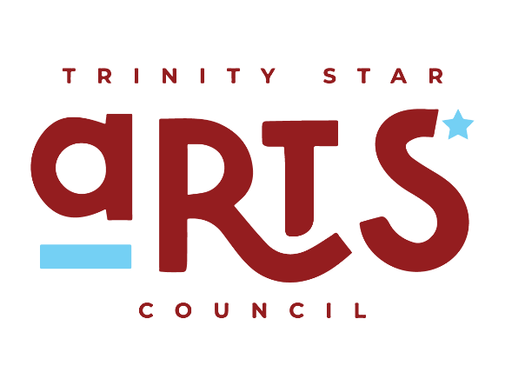

APPLICATION DEADLINE IS APRIL 17, 2023

